Online Fashion Store

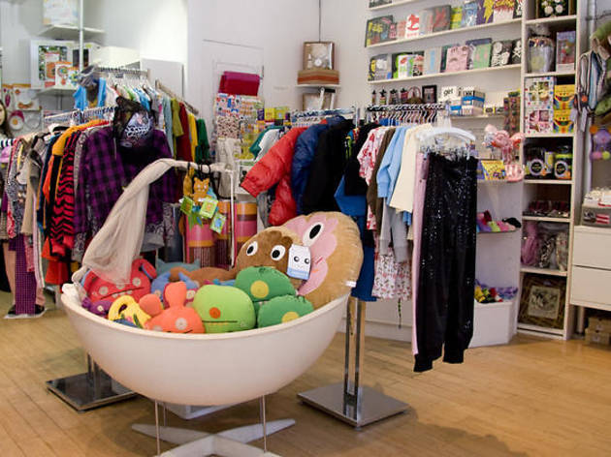

|  |  |
| --- | --- |
| Name | IT Number |
| IT17184304 | Jayagoda N.M. |
| IT18001594 | Adheeb S.M. |
| IT18044928 | J.L Thilini Randika |
| IT18016444 | I.G Hansani Yasodya |

**Table of Content**

1.0 High Level Architectural Diagrams

1.1 User Management System 3 - 4

1.2 Inventory, product Management and Order Managemnent System 5 - 6

1.4 Mycart , wishlist & Payment Management System 7

1.5 Feedback Management System 8

2.0 Assumptions and Introduction about components

2.1 User Management System 9 - 10

2.2 Inventory, product Management and Order management System

2.4 Mycart , wishlist & Payment Management System

2.5 Feedback Management System

3.0 The End

1. **High Level Architectural Diagrams**

IT18044928 – J.L. Thilini Randika

* 1. User Management System

Customer side

Administrator side

IT18044928 – J.L. Thilini Randika

* 1. Inventory, Product Management and Order

IT17184304 – Jayagoda N.M.

Management System

Product Management:

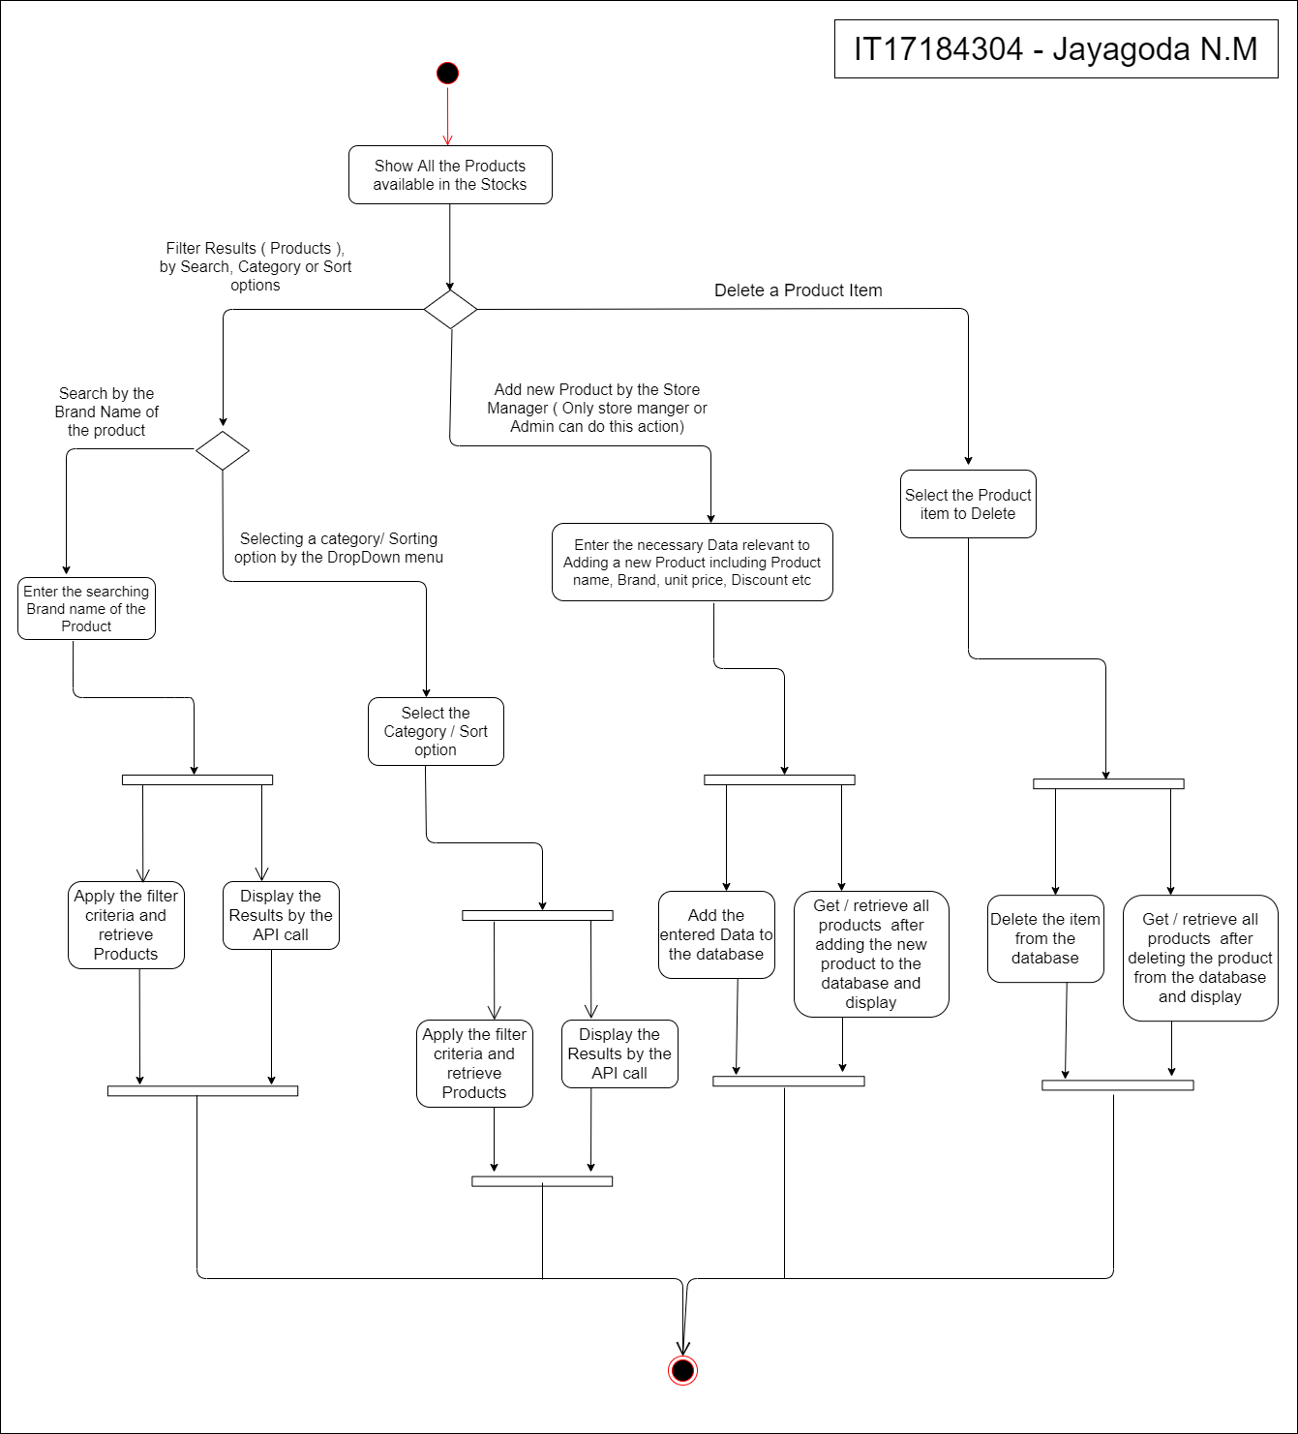

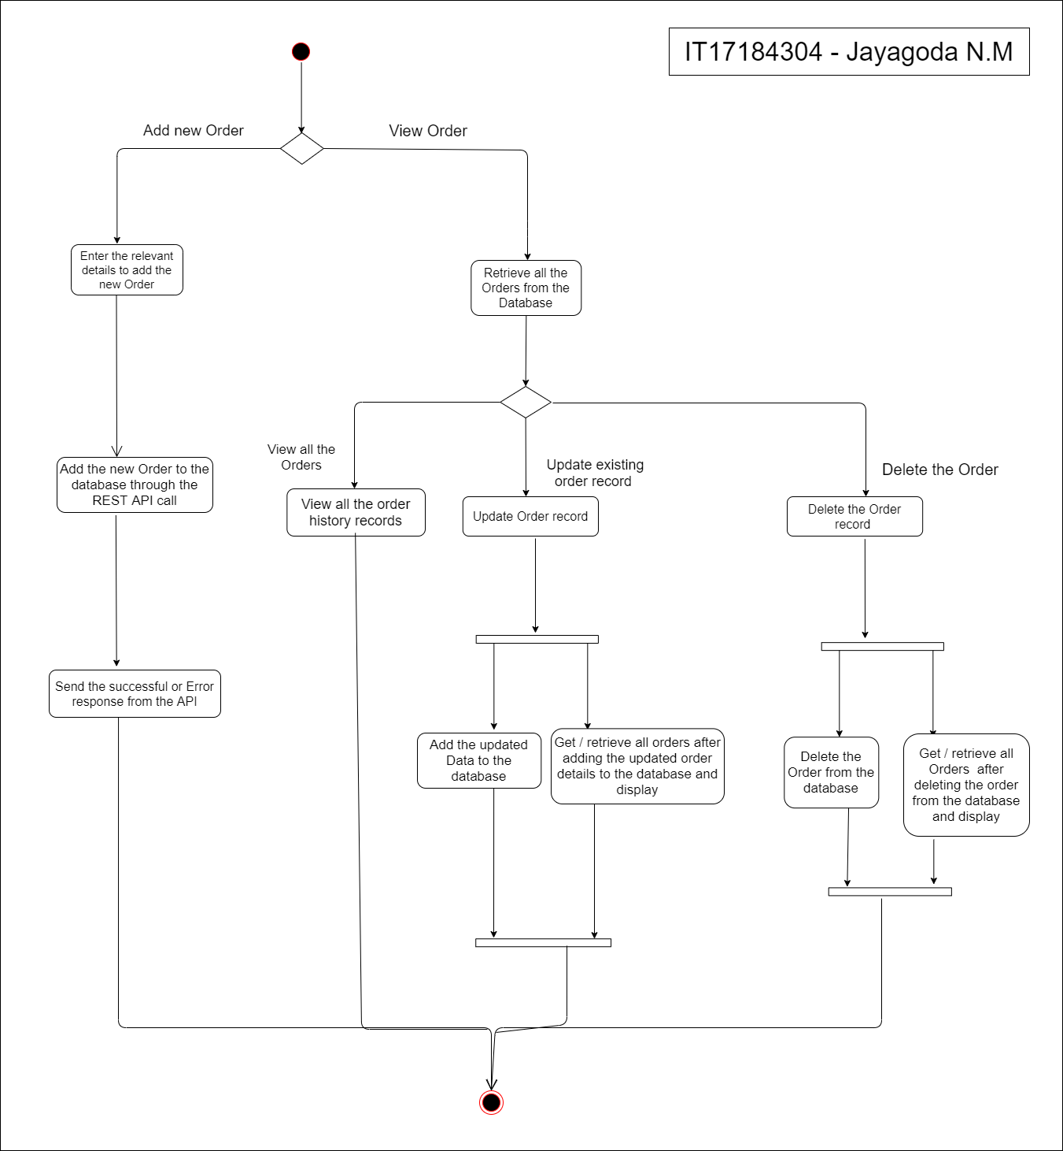Order Management:

IT17184304 – Jayagoda N.M.

* 1. Add to cart , Wishlist and Payment Management System

IT18001594 – Adheeb S.M.

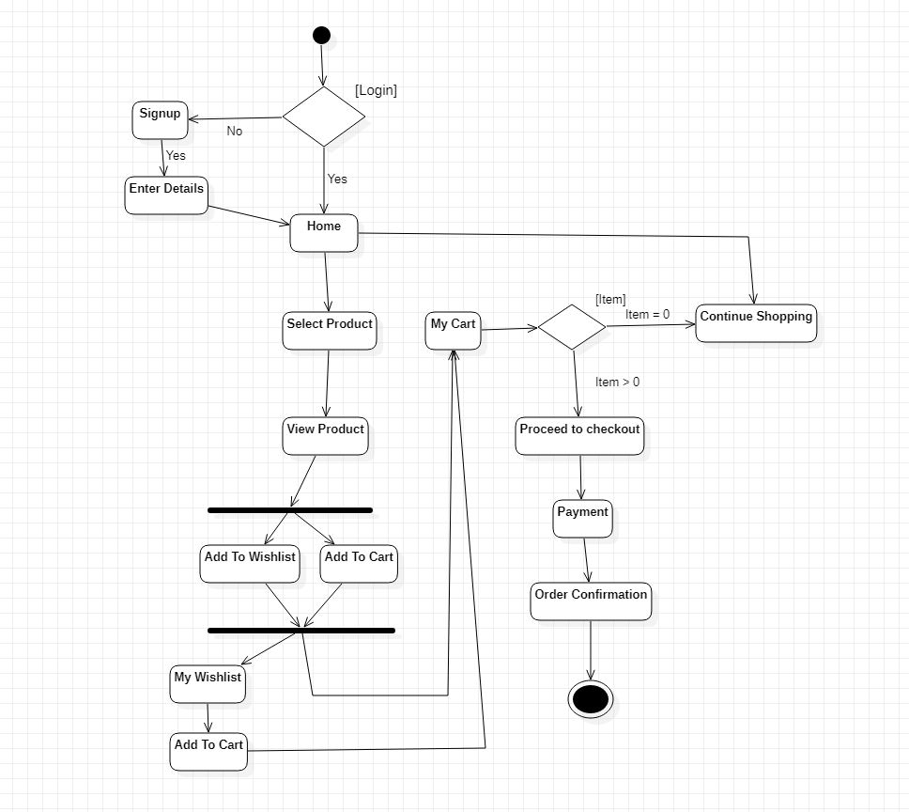

* 1. Feedback Management System

IT18016444 – I.G. Hansani yasodya

1. **User Management System**

IT18044928 – J.L. Thilini Randika

2.1User Management System

Customers must have an account to order a product. To create an account, simply click on the Register button on the home page and fill in the form. There you have enter the name, phone number, valid email, and password. If the valid email is not provided or the password and confirm password does not match or some input field is empty, the form is not registered.

Customer can login here with email and password. If the user hasn’t an account, he/she can go to the register page using the” create an account” link

IT18044928 – J.L. Thilini Randika

The Administrator can log into the user management system using his email and password. He can change the user's privileges. Admin modifies the privilege as this customer as a user and employee as a stock manager. If admin is appointed as stock manager, it will notify stock manager by email. If an employee or user leaves the system, the administrator must click the Delete button to remove his or her details. If an administrator wants to search for an employee or customer, he can do so using the search bar at the top.

Click on the username next to the logout in the navbar and my profile will load. This will show the user details and user can edit them and delete user profile account. When user delete her/his account it automatically redirects to the login page.

My git link - https://github.com/thilinijayasekara97/FashionStore-UserManagement.git

2.2 **Inventory, Product Management and Order**

IT17184304 - Jayagoda N.M.

**Management System**

# Products Management:

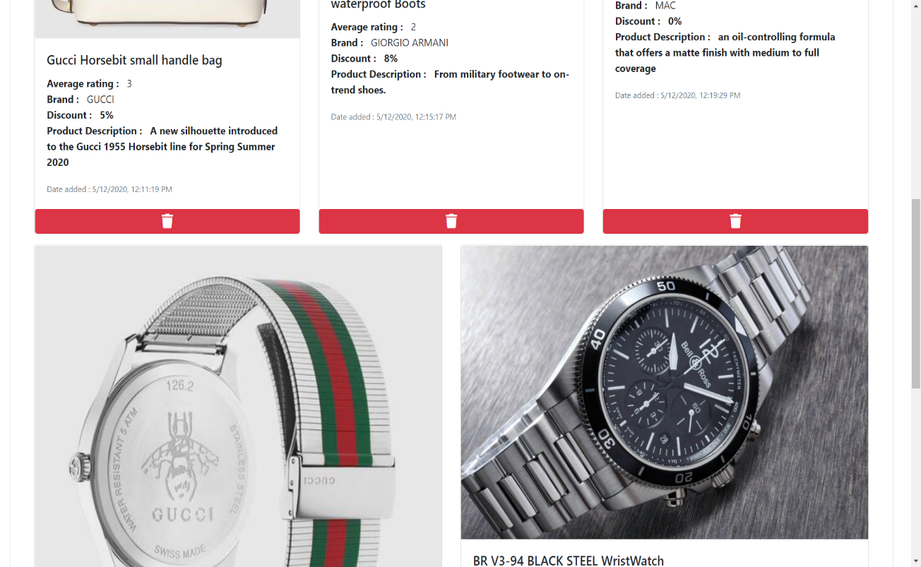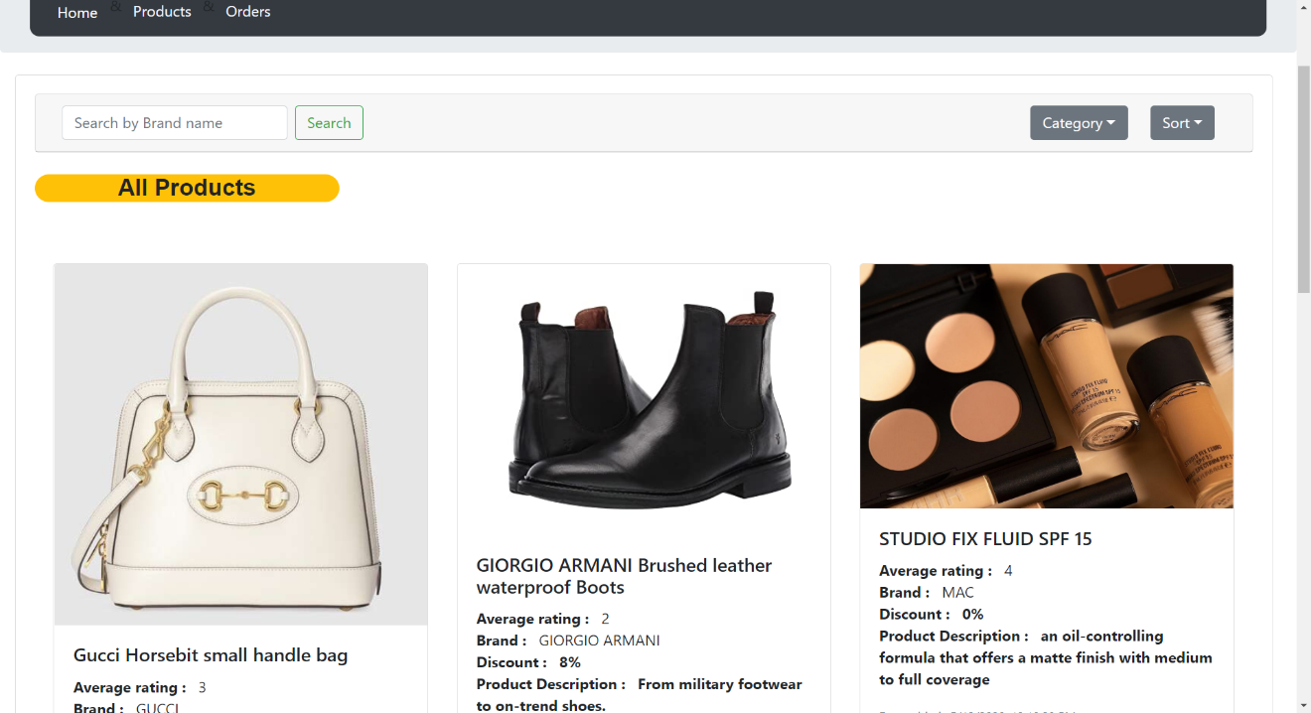

Any visitor to the site can view all the products ( visitors and logged users can only view products items, no modifications to the existing items can be done ) meanwhile store manager can add or remove products from the system. Above is the screen available for the **Store Manager** where he/she can delete the product item as their wish by clicking the delete button in red with the bin icon under each product item.

IT17184304 - Jayagoda N.M.

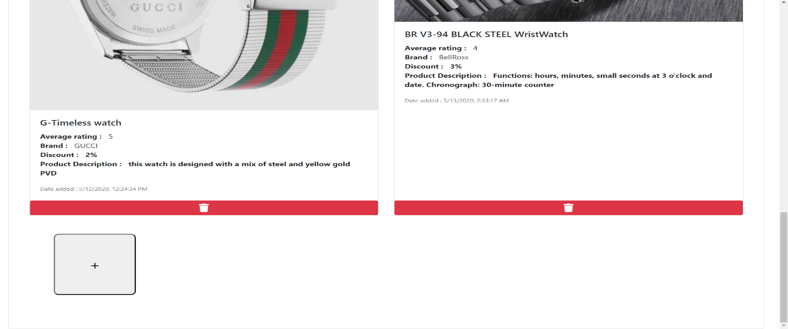

In order to add a new Product item to the system, use the Add button ( + ) at the end of the page, as shown in the above diagram. When clicked on the plus button, it will lead to the below screen.

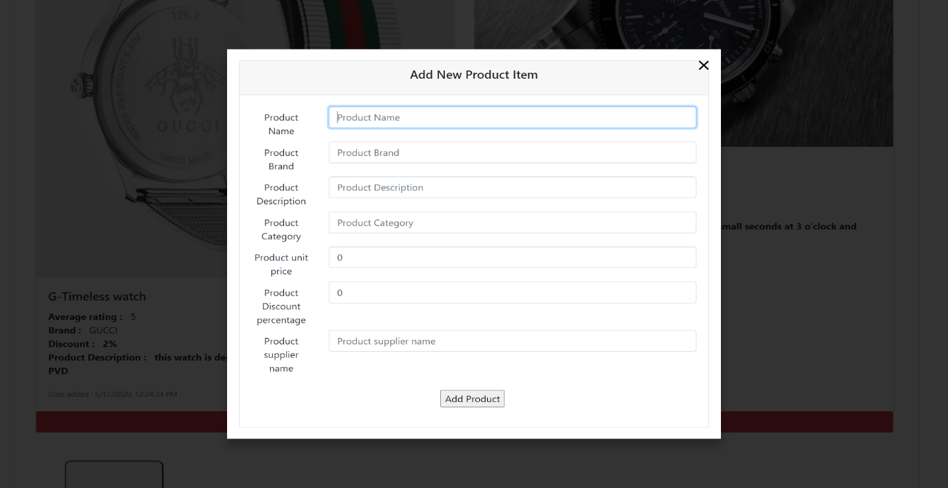

Upon valid entries into the above fields, Store Manager can add new items into the database.

IT17184304 - Jayagoda N.M.

Also, a visitor or a logged in user can Search a product item by the brand name or by the category or by sorting out from rating, latest products etc.

* *Search by product brand*

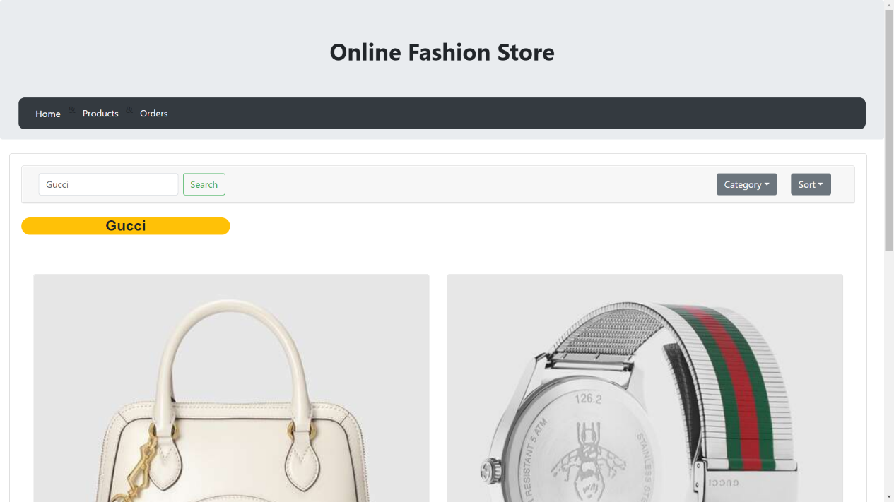

* *Filter results by Category*

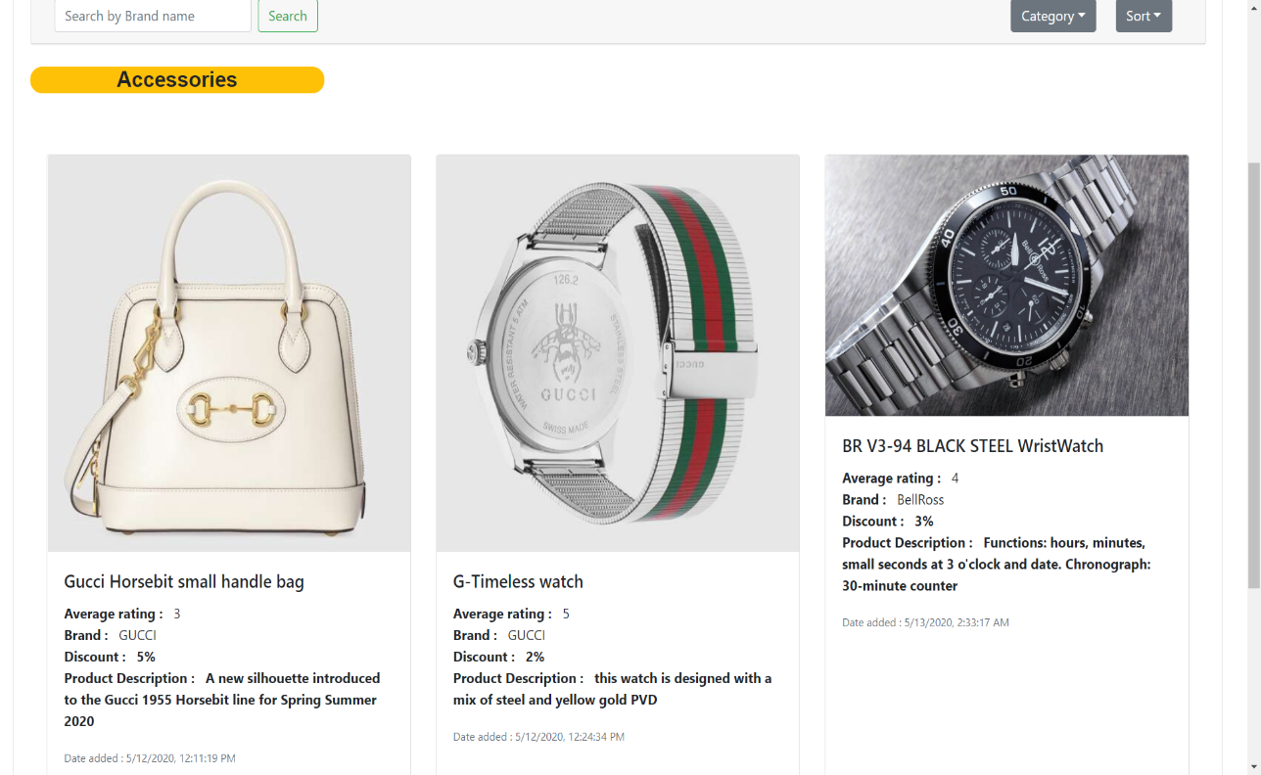

IT17184304 - Jayagoda N.M.

* *Filter results by date added (latest) / Ratings of the product*

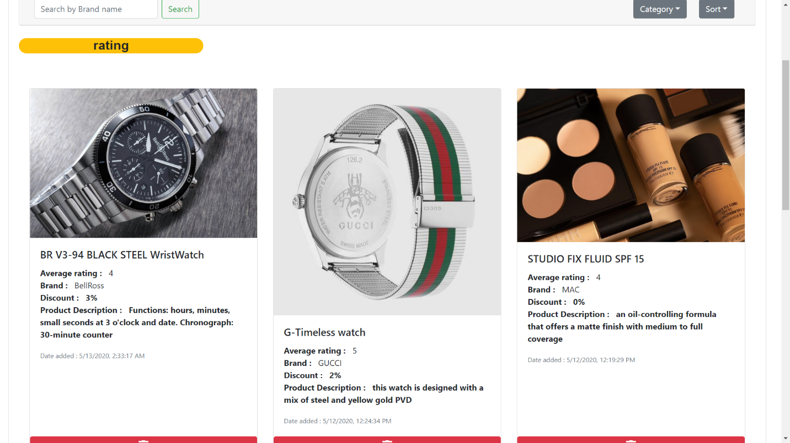

## *Order Management:*

IT17184304 - Jayagoda N.M.

Orders are transactions that regularly happening in the store with Customers and Suppliers of varying Product Items. It is a necessity to handle them properly to lead a business successfully. Order screen is only visible to users logged in as **Store Manager** and as **Admin** accounts. Below is the screen to view all the Order history and transactions.

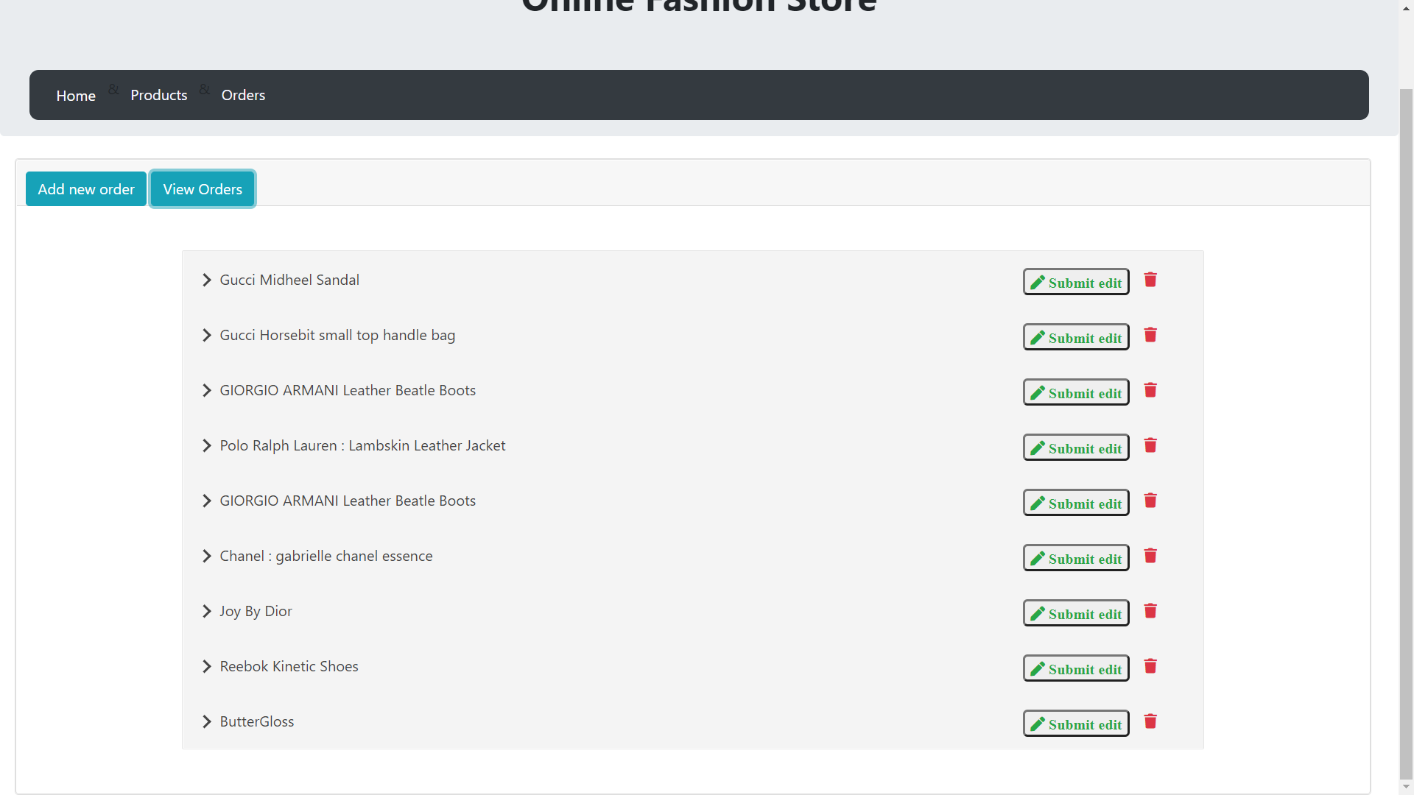

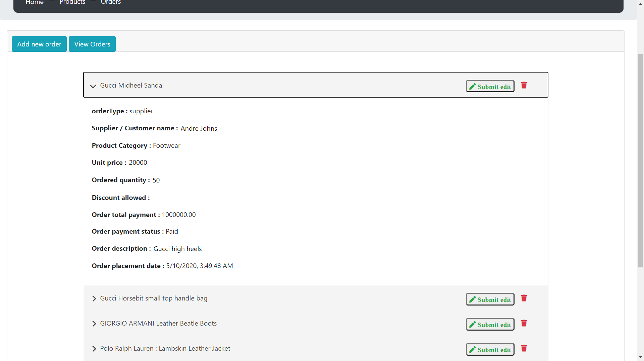

IT17184304 - Jayagoda N.M.

Adding a new Order record ( a new transcation ) can be done by the Store manager or the Admin via the below screen by entering all the relevant information:

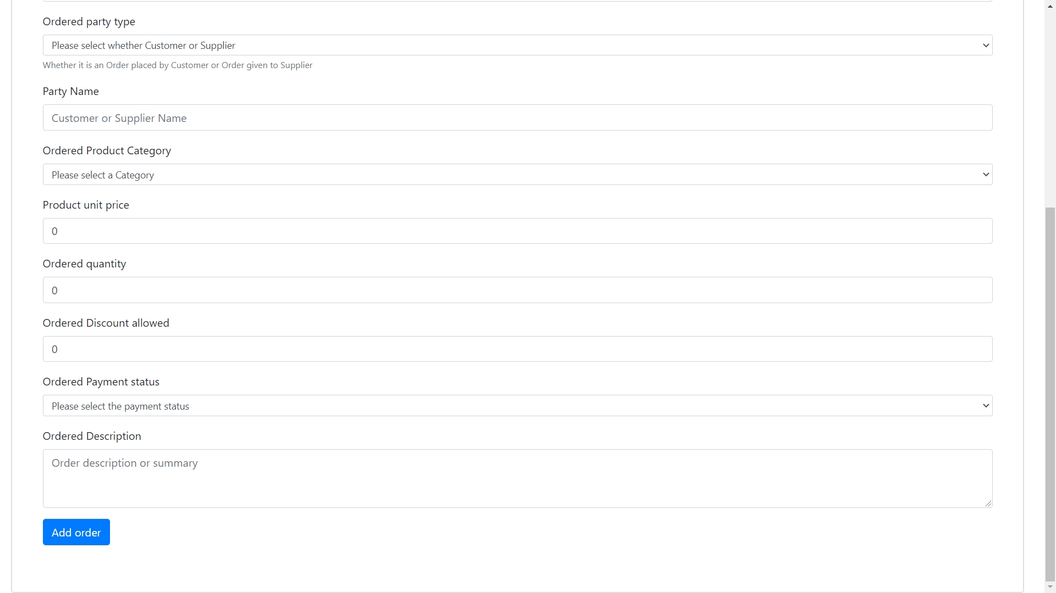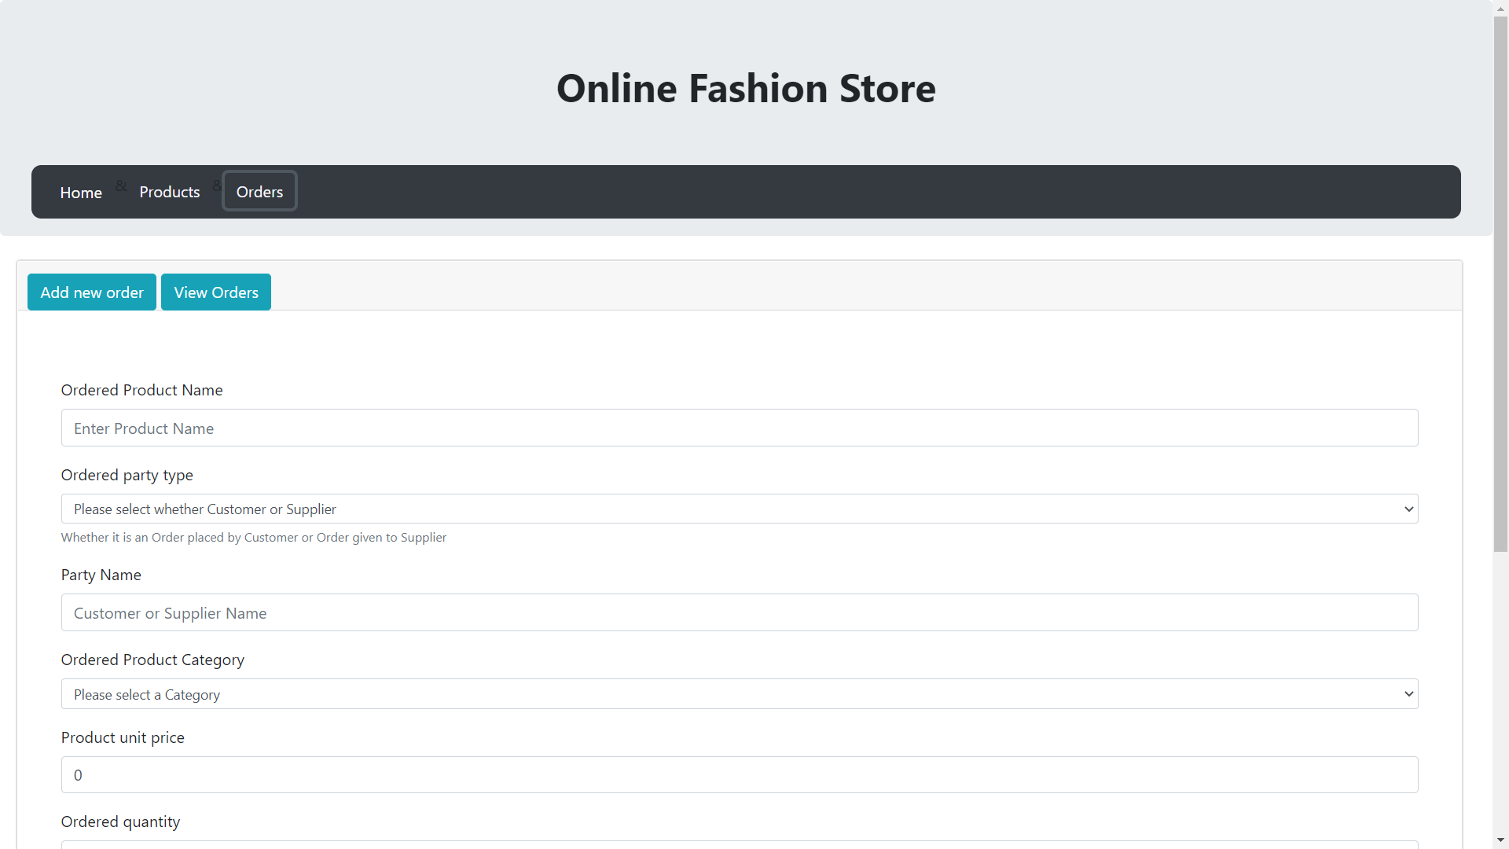

IT17184304 - Jayagoda N.M.

Also orders can be edited or deleted from the history, whenever a change is essential. For deleting a order use the bin icon in red at each order record item, in the right hand corner:

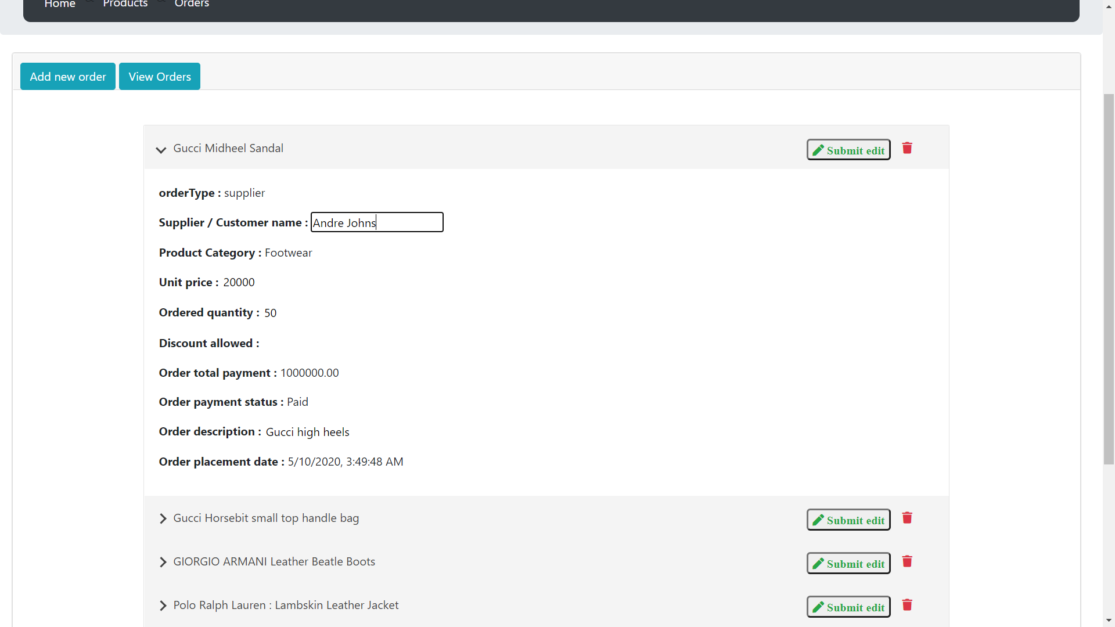

2.3Add to cart , Wishlist and Payment Management System

IT18001594 – Adheeb S.M.

User can add products to Wishlist from Product List page by clicking on the pink ‘Heart Shaped’ button.

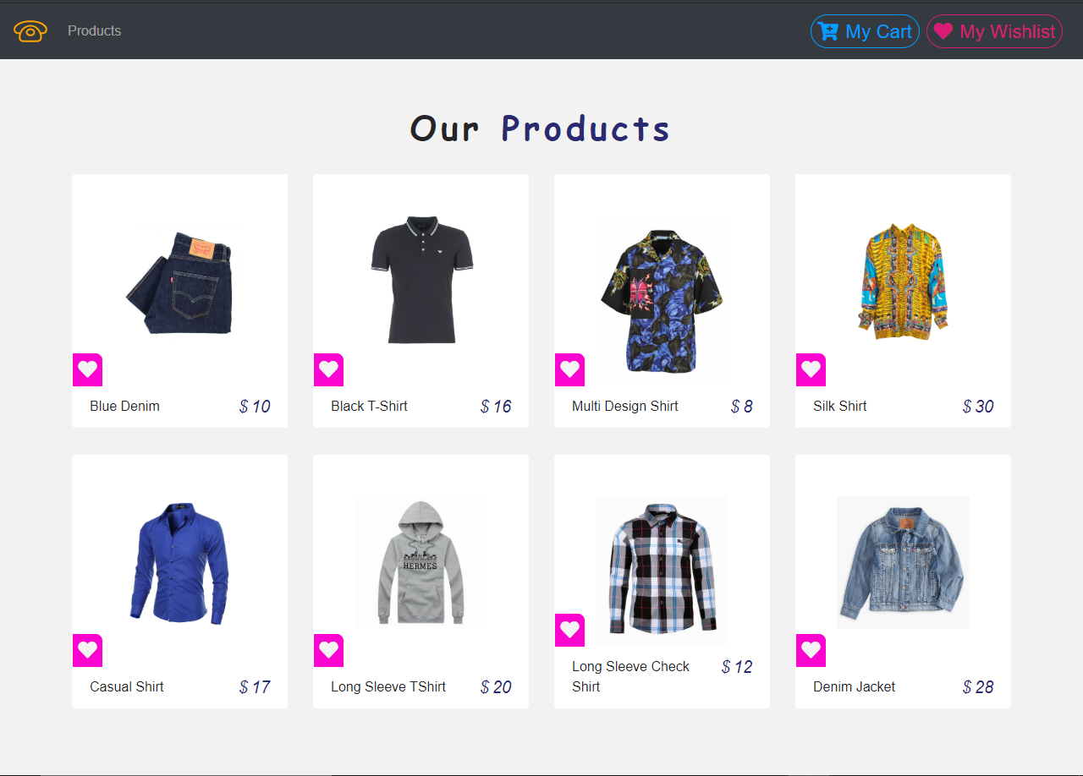

In Wishlist page, we can view the details of the item, delete the particular item or also add that item to the cart.

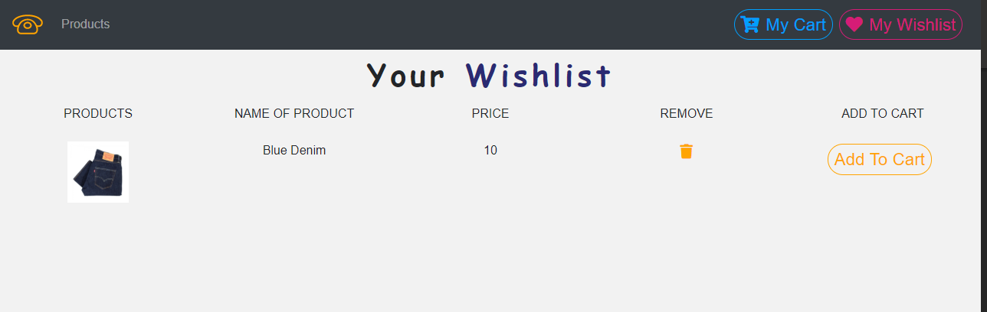

IT18001594 – Adheeb S.M.

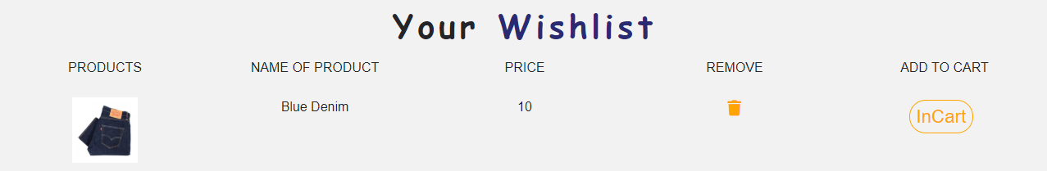On clicking the ‘Add to Cart’ button, item will be displayed as ‘InCart’ and item will be added to Cart.

Item can also be added to cart through the Product List page, by hovering over an item an clicking on the blue cart button.

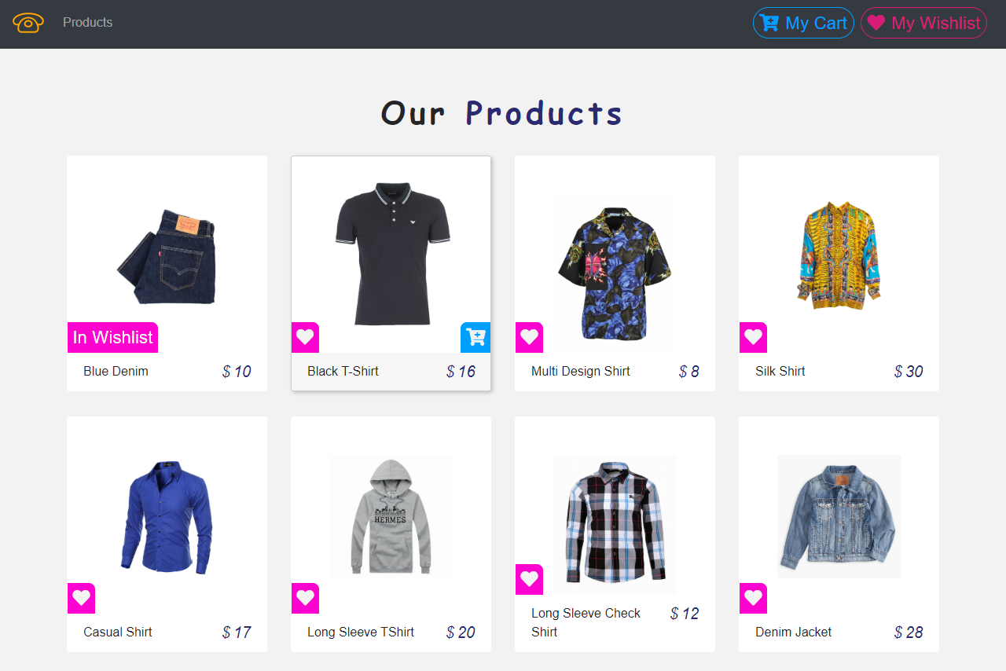

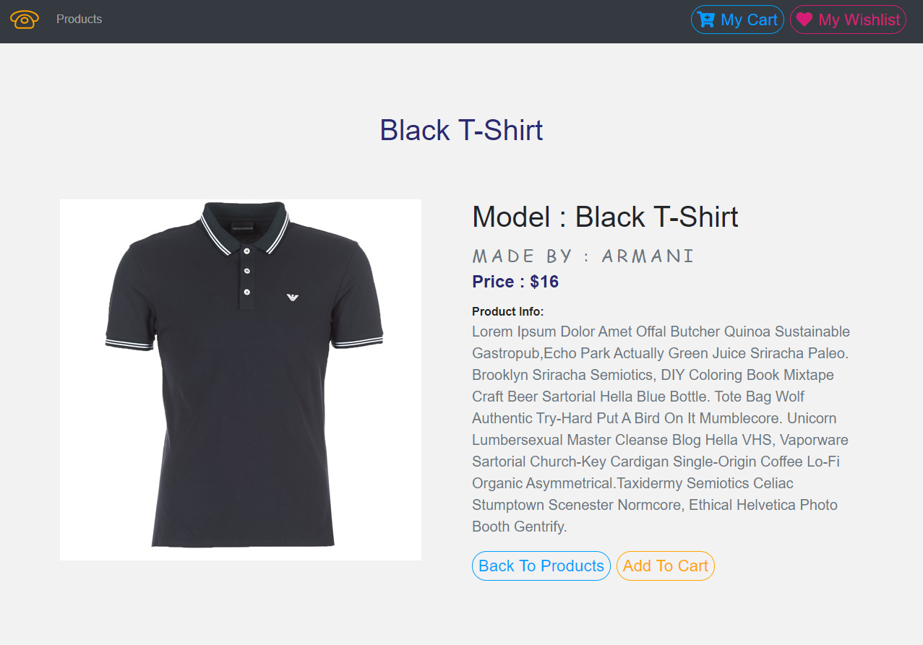Also, if we click on an item, we will be able to see its complete details.

IT18001594 – Adheeb S.M.

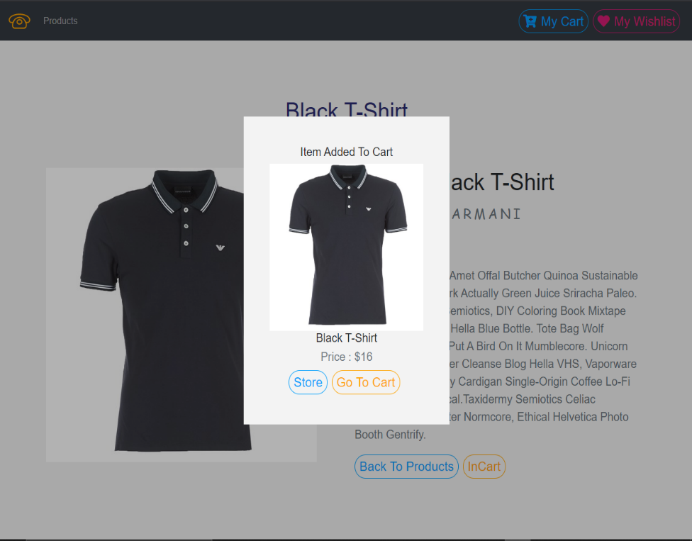By the clicking on the ‘Add to Cart’ button, item will be added to the Cart.

IT18001594 – Adheeb S.M.

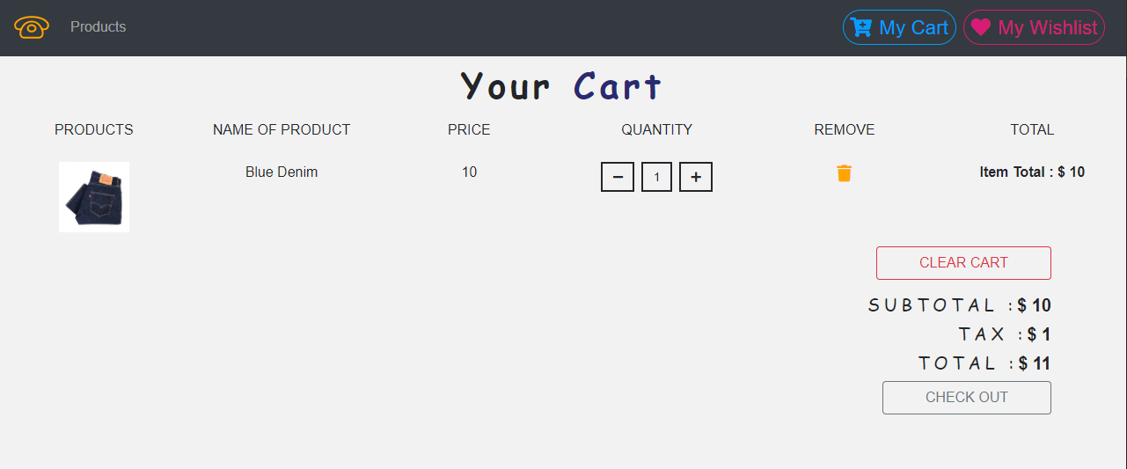

In the Cart page, we can increase/ decrease the quantity of the item, remove a specific item or completely clear the cart.

The Total amount of the items will be displayed accordingly.

Once all items have been reviewed, user must click on the checkout button and user will be directed to Payment page.

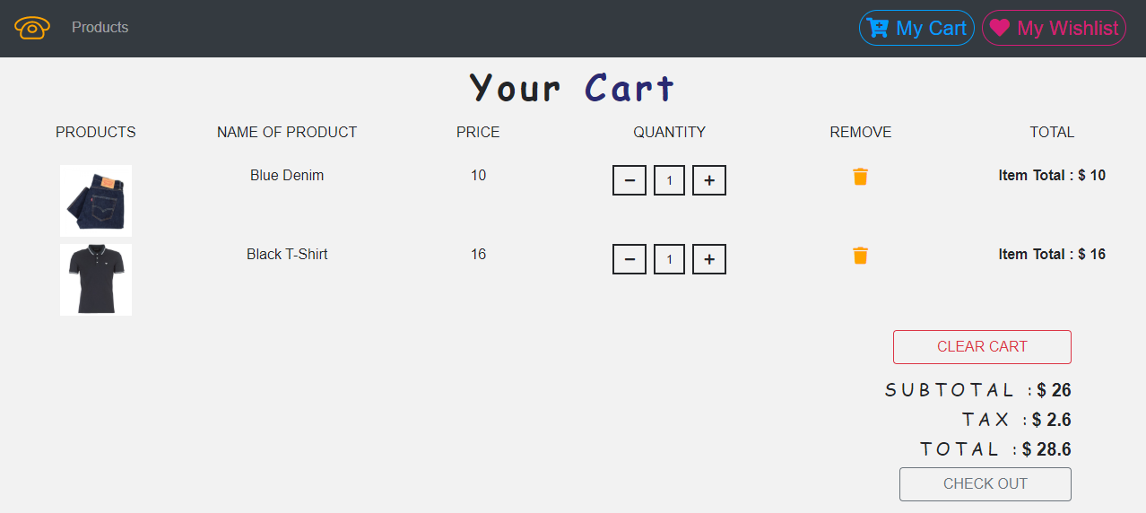

IT18001594 – Adheeb S.M.

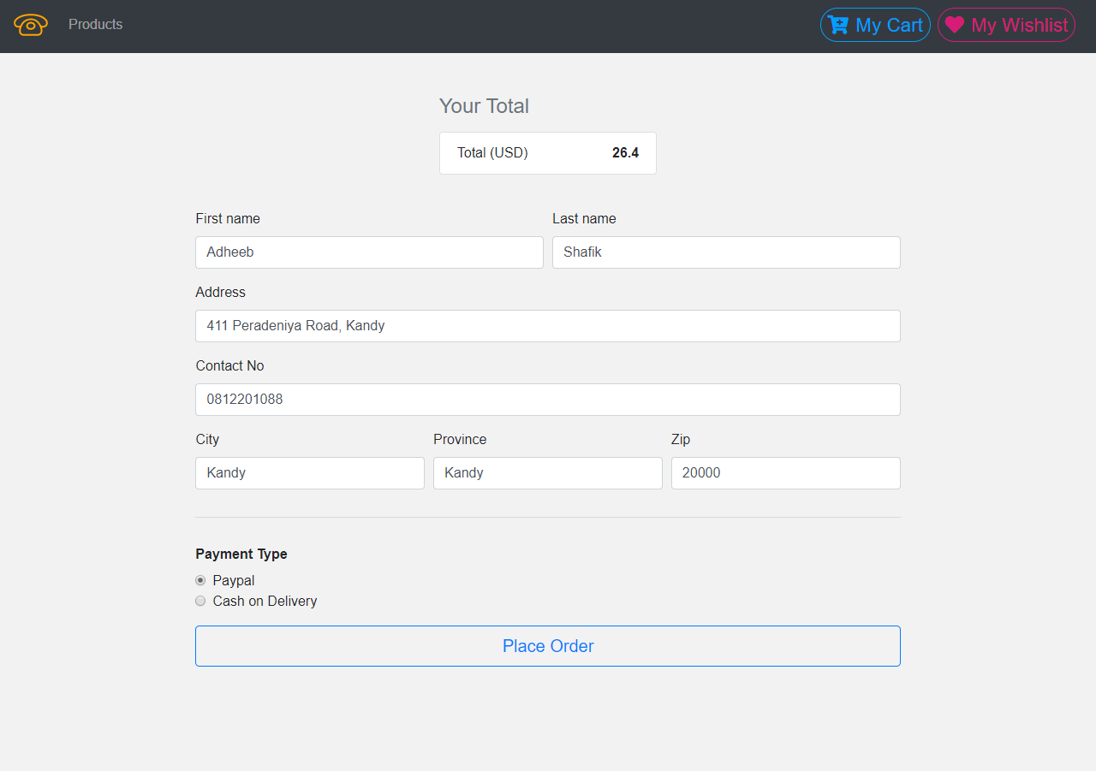

In the payment page, the total to be paid will be displayed.

The User then has to fill in the relevant delivery details and has to choose the payment method.

Then user then has to place the order

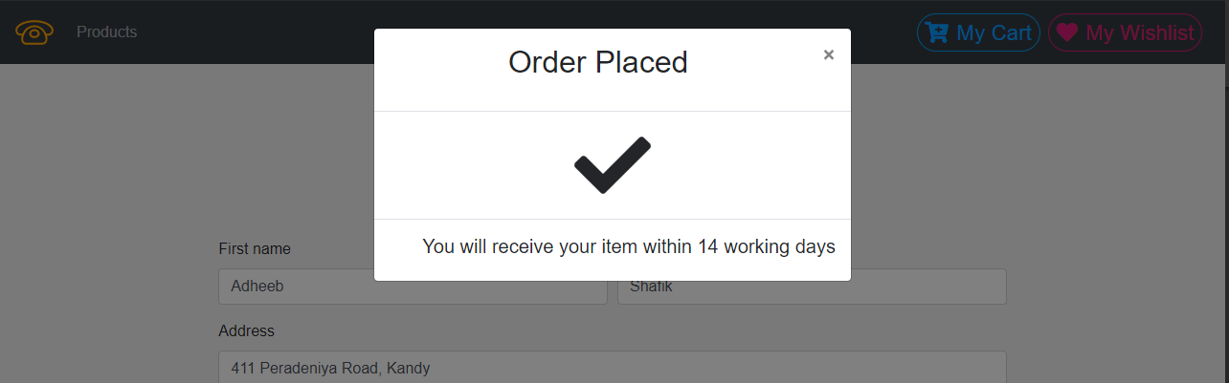

2.4Feedback Management System

IT18016444 – I.G. Hansani Yasodya

User who logged into the system by giving correct credentials can add comments to the products. In addition to adding comments the user can update and delete the comments. All the comments are displayed for each product. Users can rate the product. Then the average rating is calculated by the system for each product and display it.

The End

Thank You!